

By: Trevor Aquino, Jerry Qing, and Alex Xu

Period 4

System Requirement:

**Windows**

* Windows 10 (8u51 and above)
* Windows 8.x (Desktop)
* Windows 7 SP1
* Windows Vista SP2
* Windows Server 2008 R2 SP1 (64-bit)
* Windows Server 2012 and 2012 R2 (64-bit)
* RAM: 128 MB
* Disk space: 124 MB for JRE; 2 MB for Java Update
* Processor: Minimum Pentium 2 266 MHz processor
* Browsers: Internet Explorer 9 and above, Firefox

**Mac OS X**

* Intel-based Mac running Mac OS X 10.8.3+, 10.9+
* Administrator privileges for installation
* 64-bit browser

A 64-bit browser (Safari, Firefox for example) is required to run Oracle Java on Mac OS X. 

**Linux**

* Oracle Linux 5.5+1
* Oracle Linux 6.x (32-bit), 6.x (64-bit)2
* Oracle Linux 7.x (64-bit)2 (8u20 and above)
* Red Hat Enterprise Linux 5.5+1, 6.x (32-bit), 6.x (64-bit)2
* Red Hat Enterprise Linux 7.x (64-bit)2 (8u20 and above)
* Suse Linux Enterprise Server 10 SP2+, 11.x
* Suse Linux Enterprise Server 12.x (64-bit)2 (8u31 and above)
* Ubuntu Linux 12.04 LTS, 13.x
* Ubuntu Linux 14.x (8u25 and above)
* Browsers: Firefox

Installation Instruction:

Download Java to run the ProjectGon.jar file.

Starting the Game:

Click on ProjectGon.jar file. It will open with a menu screen with three different options. Press the Enter key while the selection is on “Start” to begin the game. It will automatically reset when the player dies or wins the game.

Objective:

The objective of the game is to make it out of a dungeon while killing enemies along the way. The player has a sword that could be used to take out each enemy. There are two different kinds of enemies, one with a simple horizontal or vertical movement and another with both kinds of movements and a faster speed. All enemies attack periodically in all four directions. The door to the next room will only open when all the enemies in the current room is dead. Each enemy only has one hit point while the player has a total of 10. The game ends when the player dies or when the player wins the game by making it out of the final room.

Controls:

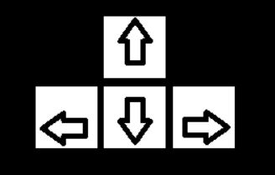

The arrow keys dictate the movement of the player. The up arrow is up, down arrow is down, right arrow is right, and left arrow is left.



The spacebar is to swing the sword to attack an enemy.



Press the “P” button to pause the game.

Player:

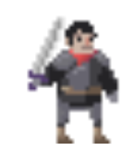This is the entity the player controls that can swing the sword to deal

damage.

Enemies:

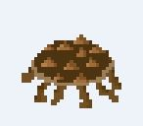 This is the first type of enemy with the basic movements. It will either

have only horizontal movement or only vertical movement. It will still

attack in all four directions as it stops. It is slower in comparison to the

other type.

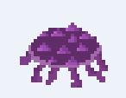 This is the second type of enemy with more advanced movements. It can

move and will always attack in all four directions. It is much faster, but it

still does the same amount of damage.